Computer Science Project

Mystic swords

Using Python

**Done by**

**S.Manoj Srivatsava**

**ACKNOWLEDGEMENT**

We hereby acknowledge all those people, who have helped for the successful completion of our project to a great extent.

We would also like to convey our sincere gratitude to our principal Smt. J. Geetha and the D.A.V School management for having provide us with complete access to all materials and information source available in the computer laboratory.

We express our deepest gratitude to our Computer Science teachers for their encouragement during the course of the project titled “Mystic Swords”

We would also like to extend our thanks to other members of the computer department for their co-operation.

**Team Members:**

25 - S.Manoj Srivatsava

**Introduction**

Video games otherwise know as computer games where the pinnacle of entertainment around the 1970’s. These video games are classified based on the platform their played in, like arcade game’s consol game’s…etc.

After the arrival of the Internet multiplayer games over long distances was possilbe which skyrocketed the popularity of vedio games.

One category of vedio games at that time were called top down games, some examples are space invaders,lunar lander and pong the first top down game ever made was called spacewar! Made in 1962.

These top down games got better with time and evolved to games like pokemon ruby, pokemon emerald.The game that I will be presenting as the cs project is also of the top down variety

**MYSTIC SWORDS:**

This game is partially based on greek mytholigy as the main character in the game is based on Thesius and the sword that he weilds which was given to him by Ariadne

In this games story Thesius uses the sword that was given to him to prevent the ghosts from reaching his city of Troezen.The game progresses by waves timing how long “Thesius” can defend his city from the ghost.The time is recorded and stored in a binary file which can be accessed later ingame for the highscores.The speed and number of ghosts increase along with the wave.

This game was made using python and a popular library in python for game development called pygame and open cv for the loading screen

**Software Used**

Python 3.11 on Windows 11

Python Modules Used:

* pygame
* threading
* random
* time
* pickle
* open cv
* datetime

The scores are stored into a separate binary file named highscore.dat

Textures were loaded from

The font used in the game were from

• [https://www.fontspace.com/angel-rhapsody-font-f492000](https://www.fontspace.com/angel-rhapsody-font-f49200)/ (For the text used)

The background map was made using the textures from

•https://game-endeavor.itch.io/mystic-woods (For the map)

The menu background and loading screen are from

•https://www.youtube.com/watch?v=MPiILYNStd8

**Flow Diagram**

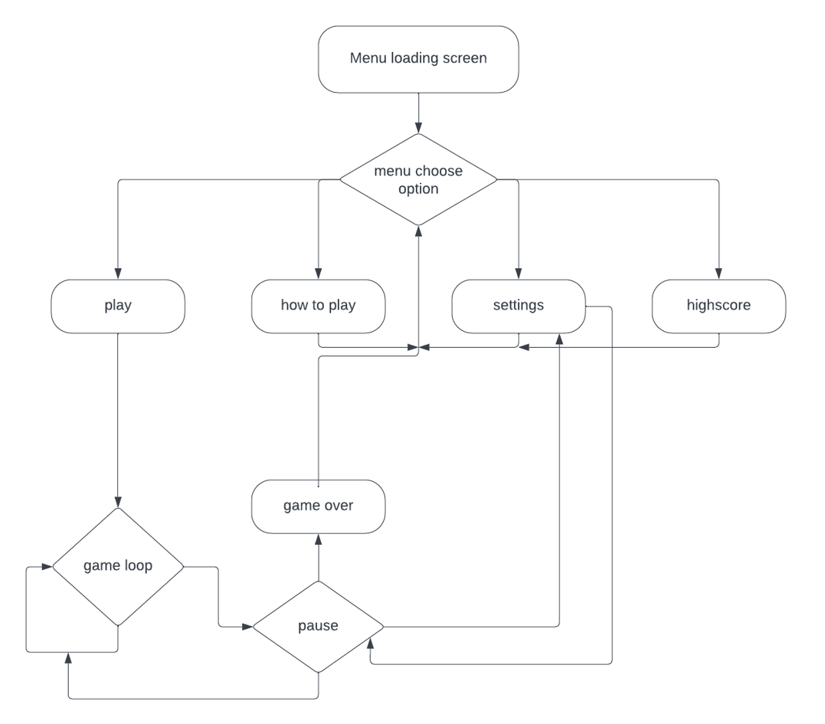

**Application Flow:**

**Loading screen**

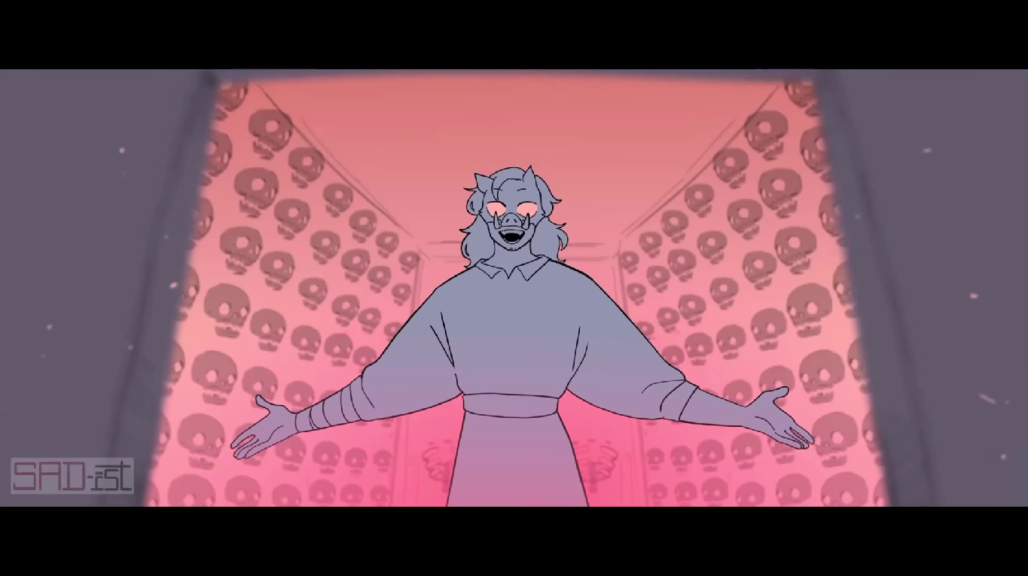

**Main menu**

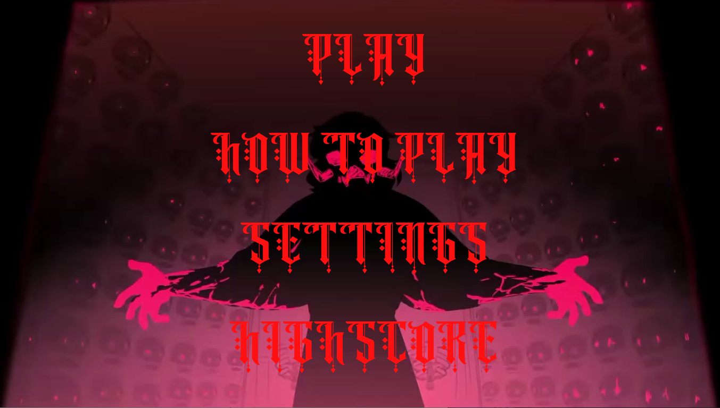

**How to play screen**

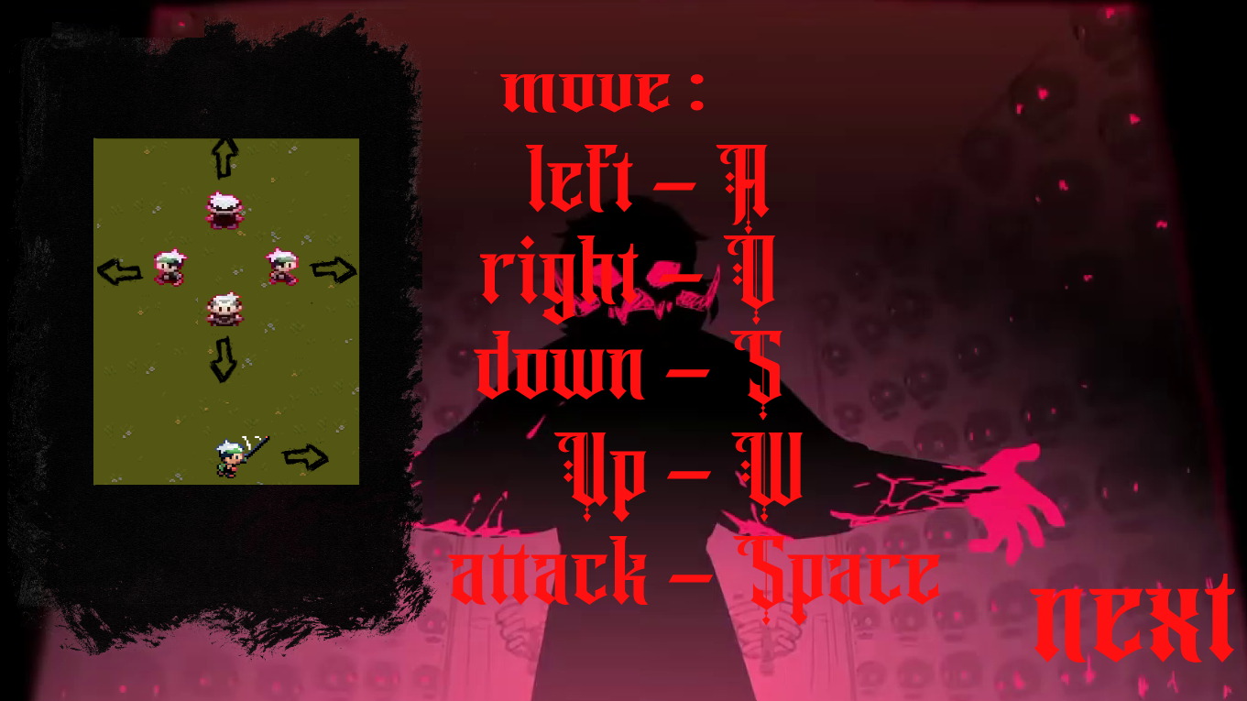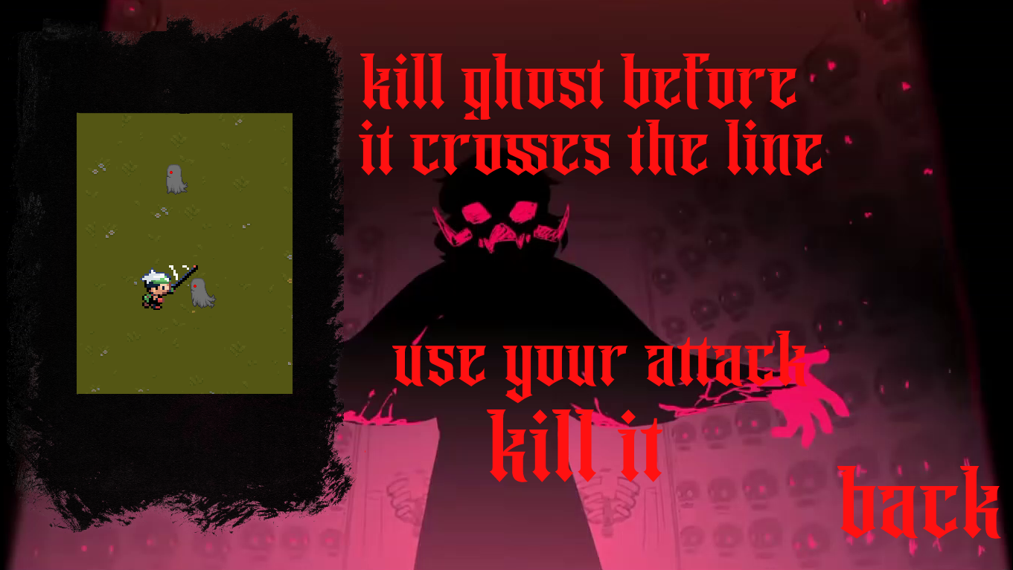

**Settings**

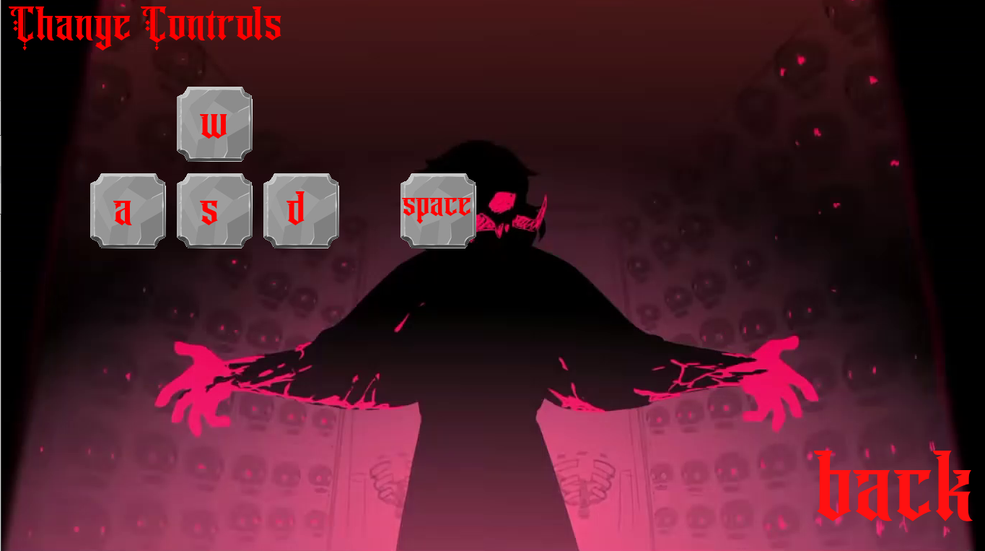

**Highscore**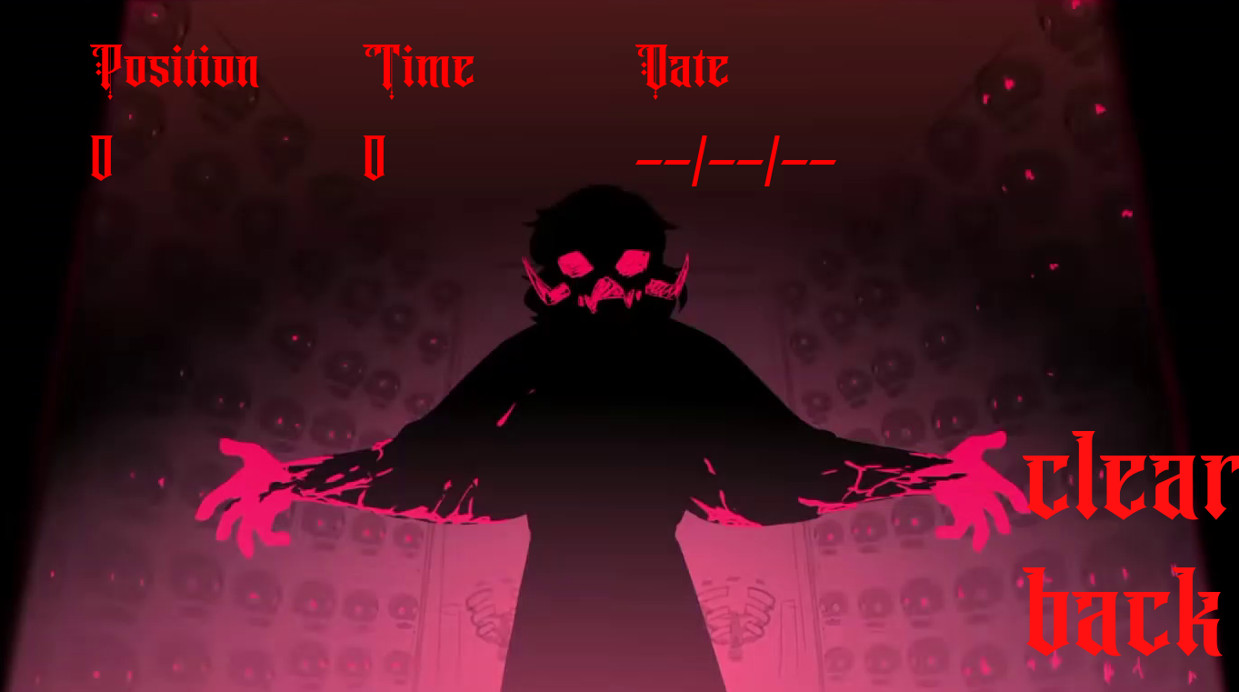

**Game screen**

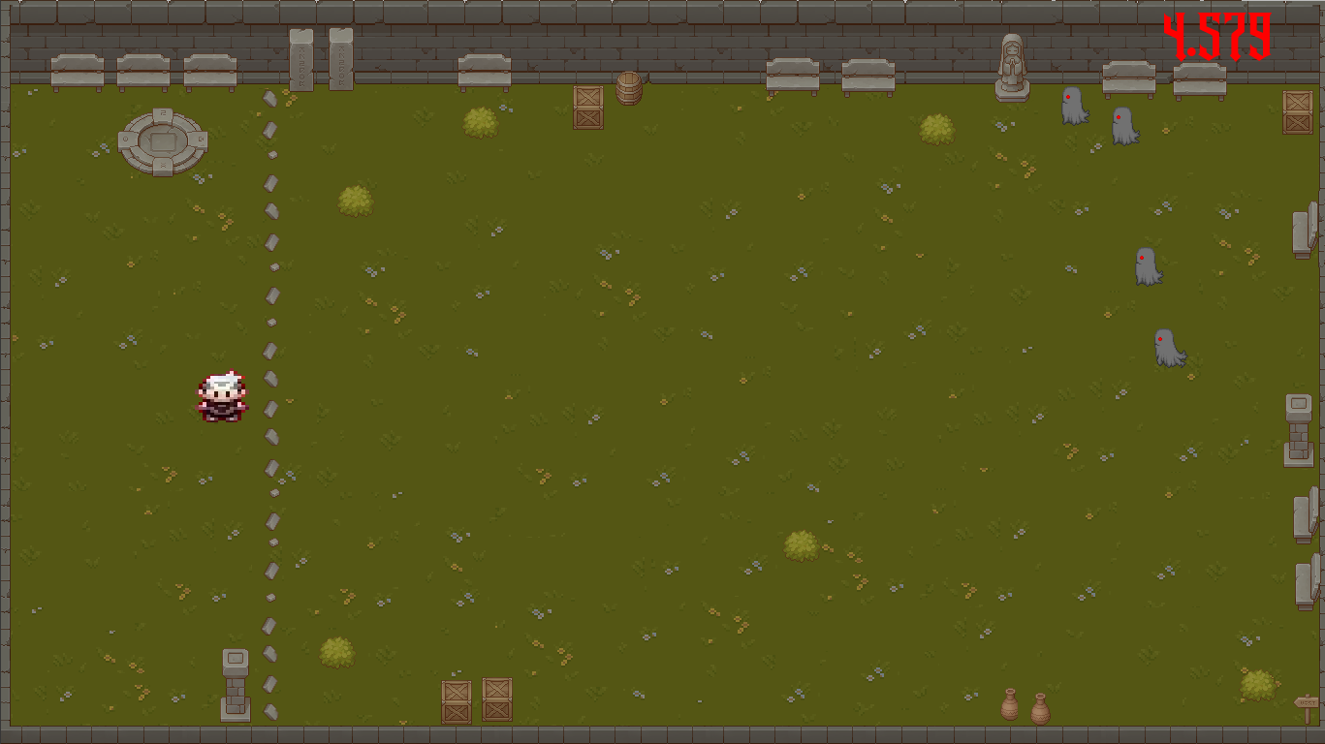

**Pause menu**

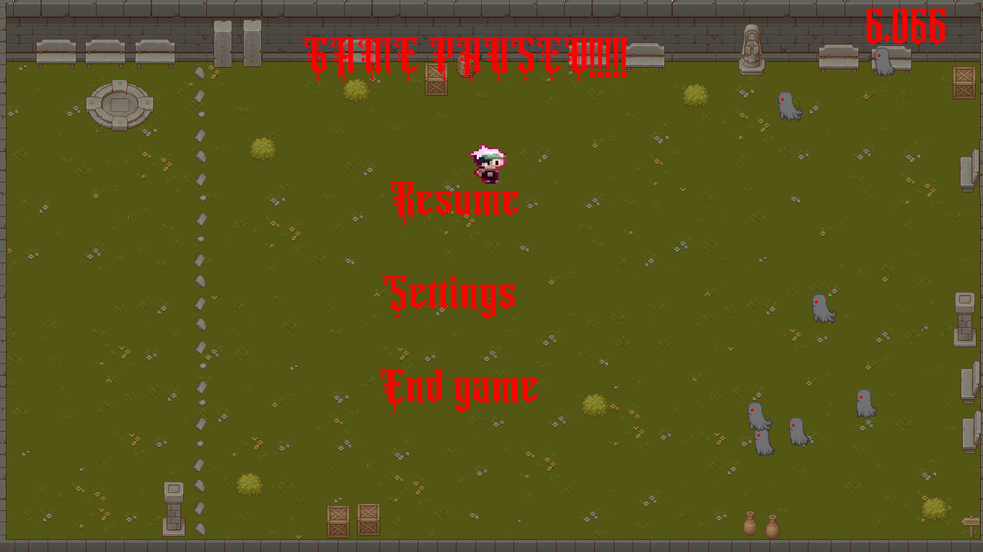

**Game over screen**

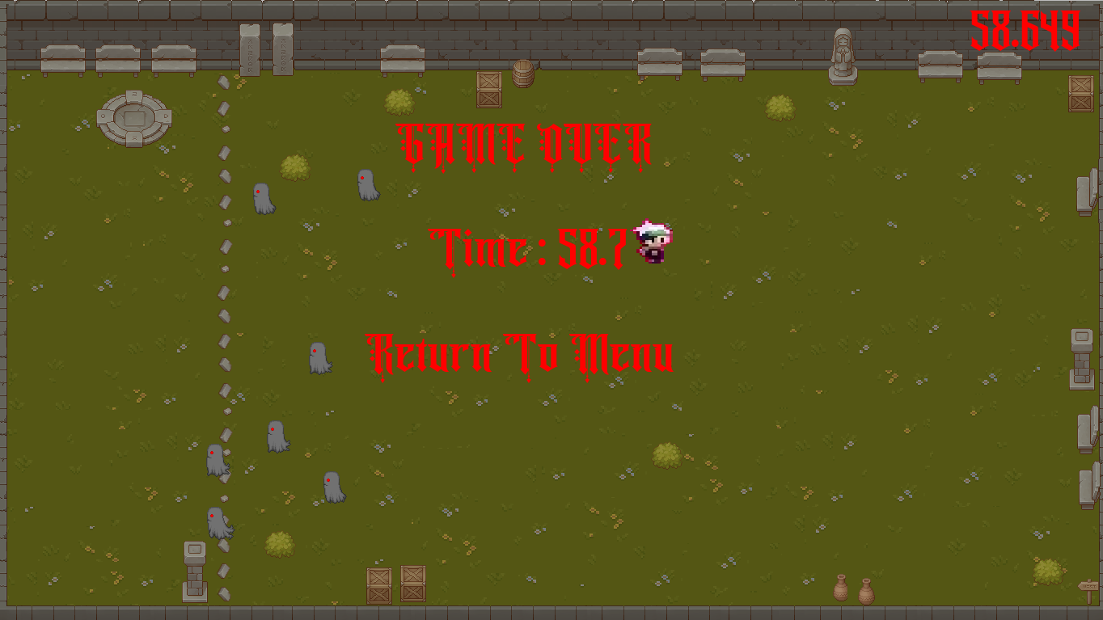

**Files part of the project**



main.py



menu.py



settingsdisplay.py



Highscoredisplay.py



Singleplayer.py

AngelRhapsoy.ttf

 Highscore.dat

**Bibliography**

• https://www.pygame.org/docs/